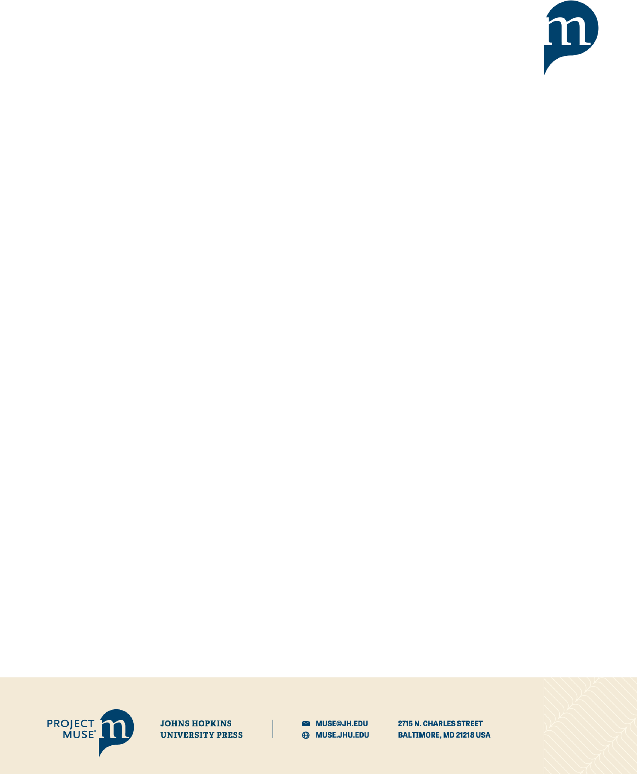**EVIDENCE-BASED ACQUISITION OF**

**BOOKS ON PROJECT MUSE**

Evidence-Based Acquisition of Books on Project MUSE provides libraries with an option to open up discovery and access for a critical mass of current, essential scholarly books, allowing faculty and students to find and make use of the most relevant content for their research and teaching. The user experience is as if the institution already owns the book, **with unlimited simultaneous usage, downloading and printing of DRM-free PDF chapters**. The library can track which books are receiving the most use through standardized usage reports, and select for permanent acquisition those titles best suited for its collections. The access available via an EBA program also allows library subject selectors to more thoroughly review book selections recommended by faculty or approval profiles before making purchase decisions.

EBA programs may be tailored to meet specific collection development needs and budgets, by limiting the access pool by publication year, publisher, language of publication, subject or price. Libraries may also supplement purchases of MUSE Book Collections in core subject areas with EBA, to identify desirable books outside the core collection scope.

Content Available: All books made available by the publisher for single title sale on the MUSE platform may be included in an Evidence-Based Acquisition (EBA) program. EBA programs may include both newly-released titles and backlist books. Publishers opt their titles in for single title sales on MUSE and may change this option at any time. **More than 94,000 titles are currently EBA-eligible**.

**Our newly added Latin American books program** [**https://about.muse.jhu.edu/muse/publishers/books/**](https://about.muse.jhu.edu/muse/publishers/books/)has added 400+ publishers to our existing 200+ publishers contributing content.

**Program Outline:**

* Project MUSE and Customer agree on EBA program parameters (Library budget commitment, Length of term, Content filters if desired, Price multiplier if applicable for consortia or library system)
* EBA agreement is signed and MUSE bills customer for entirety of budget commitment
* Access to content is enabled, and customer is provided with a personalized EBA management page which includes MARC records/KBART/title list downloads, usage statistics, and title purchasing tools
* Newly-published books eligible for the library’s EBA program may be accessed immediately on release
* Usage statistics (COUNTER-based) for EBA title set provided on monthly basis for customer review, quarterly reports pushed to library along with a program-end report including current book prices
* Purchasing tool allows for title selection and billing at any time throughout program period; selected titles billed against funds deposited at beginning of program; price for each title is set by the publisher
* Access disabled at end of program period for all content not purchased and billed; library has 30 days past end of program to make selections to spend out entirety of budget
* Programs may be renewed, with an additional budget commitment, and adjustments to content set as desired

**Project MUSE Evidence-Based Acquisition Content Snapshot**

(*Currently more than 94,000 titles from over 600 publishers, with new content added daily*)

**See a list of all Project MUSE participating publishers, nearly all of whom have books available in our EBA programs, at https://about.muse.jhu.edu/muse/publishers/books/.**

**Filter your content set by any of the following subjects or disciplines:**

*African Studies*

*American Studies*

*Archaeology and Anthropology*

*Art and Architecture*

*Asian and Pacific Studies*

*Classical Studies*

*Ecology and Evolution*

*Education and Rhetoric*

*Film, Theater and Dance*

*Gender Studies*

*Global Cultural Studies*

*History*

*Jewish Studies*

*Language and Linguistics*

**Titles by Publication Date**

*Latin American and Caribbean Studies*

*Literature*

*Middle Eastern Studies*

*Music*

*Native American and Indigenous Studies*

*Philosophy and Religion*

*Poetry, Fiction and Creative Non-Fiction*

*Political Science and Policy Studies*

*Psychology*

*Public Health and Health Policy*

*Russian and East European Studies*

*Science, Technology, and Media*

*US Regional Studies* Titles by Publication Date

|  |  |  |  |
| --- | --- | --- | --- |
| *Pre-2000* | 9,839 | *2022* | 4,4549 |
| *2001-2010* | 22,924 | *2023* | 4,032 |
| *2011-2020* | 58,344 | *2024* | 4,032 |
| *2021* | 5,028 | *2025* | 2,174 |
| *2026* | 8 |  |  |

# EBA Book Purchase Prices (set by publishers)